SRLS – Sandia RPM Lane Simulator  
User Guide

This document describes how to use the Sandia RPM Lane Simulator (SRLS). SRLS is a desktop application that simulates one or more radiation scanning lanes. Each lane consists of a radiation portal monitor (RPM) and up to two internet cameras. The sections that follow cover installation, use, and internal algorithms of the simulator.

# Installation

SLRS is a cross platform desktop application that runs on Windows, Mac, and Linux systems. The install that you will use depends on your operating system.

For Windows users, a standard Window installer (msi) is provided. Simply launch the installer and follow the prompts from the installation wizard. In most cases, users can accept the default settings.

For Mac users, TBD.

For Linux users, TBD,

# Use

The user interface of SRLS consists of two tabs: the Lanes tab and the settings tab. The Lanes tab displays all the lanes that are being simulated and allows users add to configure and control the lanes that will be simulated.

* Add and remove lanes;  
  The user can create new lane simulators and delete existing lane simulators as needed. Each simulator will simulate an RPM and up to two cameras.
* Configure individual lanes;  
  Each lane simulator is controlled by a number of parameters. The most important of these are the lane name and the IP addresses and port numbers of the RPM and cameras. The background radiation levels, alarm and fault thresholds, and configuration settings for automatic mode can all be adjusted as needed.
* Start, stop, and pause lanes;  
  Each lane simulator will be in one of three states. When in the “started” state, the RPM and cameras will have be listening for network connections and transmitting data. Lanes that are “stopped” do not have any open network connections and do not transmit data. When in the “paused” state, all network connections are open but the RPM will not transmit data.
* Trigger innocent and alarming occupancies and fault conditions;  
  Gamma, neutron, neutron/gamma alarms, and non-alarming occupancies can be triggered on each individual lane or on all lanes simultaneously. Case tamper faults can also be created and cleared.
* Adjust gamma and neutron levels;  
  Users can also explicitly set the gamma and neutron levels on each lane and can set and reset the RPM occupancy status. If the RPM is not occupied and the radiation levels are set above or below threshold levels configured for the lane, gamma high, gamma low, or neutron high faults will be generated. If the RPM is occupied, it will generate gamma alarms, neutron alarms, neutron/gamma alarms, or non-alarming occupancies, depending on the settings.

## The Lanes Tab

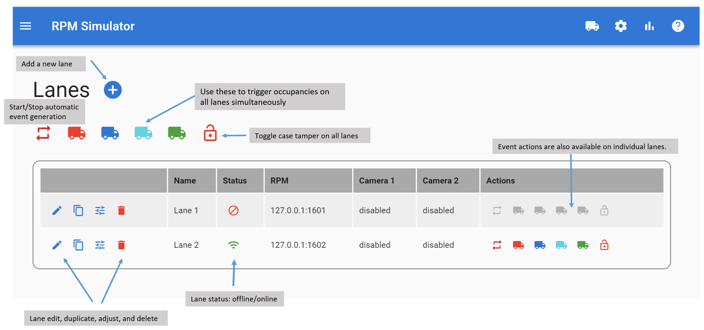

The main tab of the user interface is the Lanes tab. In this view, all lanes are displayed in a tabular format. The following items are shown for each lane.

* Lane management buttons that allow the user to edit individual lane settings, add and delete lanes, and open an interface to control the radiation levels for the lane.
* Lane status indicators that show the current lane status (stopped, running, paused) and allow the user to change the status.
* RPM can camera information.
* Buttons for triggering occupancies and case tamper for each lane.

Above the lane listing are buttons to add new lanes and to trigger occupancies and case tamper for all running lanes simultaneously.



* Toggle the lane between explicit and automatic occupancy mode.
* Generate a single gamma alarm.
* Generate a single neutron alarm.
* Generate a single neutron/gamma alarm.
* Generate a non-alarm occupancy.
* Toggle case tamper state.

### Adding Lanes

There are two ways that users can add new lane simulators. At button labeled “Add Lane” at the top of the page will create a new lane simulator and add it to the list. Alternately, the user can click on the clone button on a lane to create a new lane with the same settings as an existing lane.

### Controlling Lanes

To change the state of a lane simulator, click on the status indicator for that lane. This will toggle the lane between the started and stopped states. When in the started state, a second indicator will show if the lane is running or paused. Clicking on this indicator will toggle between running and paused.

### Triggering Occupancies

On the right side of each lane are six icon buttons that trigger occupancies and tampers. These have the same functions for generating occupancies and faults as shown above, but just apply to single lane.

### Changing Lane Settings

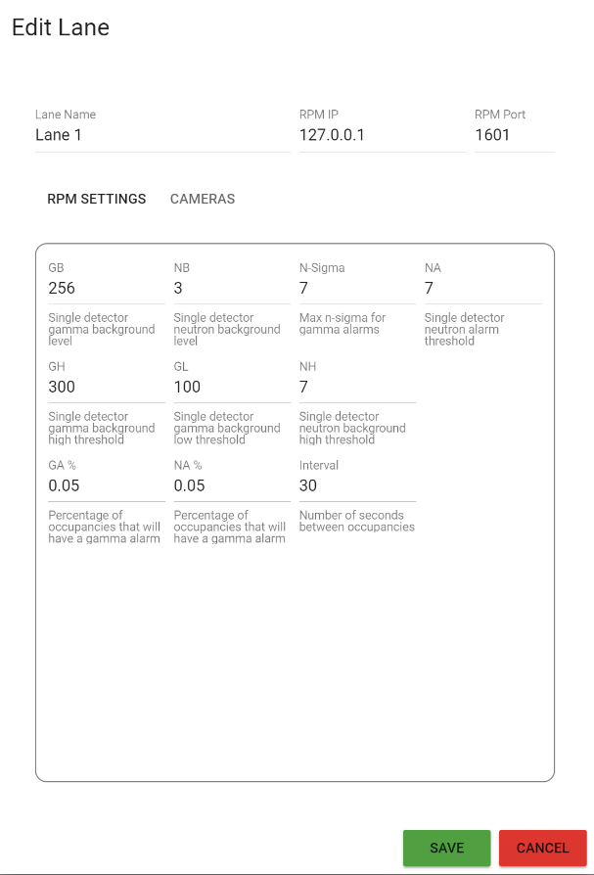

To change the settings for an individual lane, click on the pencil at the left side of the lane. A pop-up window will appear that allows the following settings to be changed.

* Lane name
* RPM IP address and port
* RPM occupancy generation method
* Camera IP address and port
* Camera image generation method
* Gamma background level;  
  This sets the mean gamma count that the lane will generate in GB messages by default. This setting is for the 5-second BG level for each individual gamma detector. The simulator will vary this value by 5% up or down for each GB message it generates. For example, if this value is set to 200, the GB messages will look similar to the following.  
    
    
  GB,000195,000203,000204,000199  
  GB,000202,000200,000205,000196  
  . . .  
  Note that the gamma background level can be overridden at any time using the real time gamma detector controls – see below.
* Neutron background level;  
  This sets the mean neutron count that the lane will generate in NB messages by default. This setting is for the 5-second BG level for each individual gamma detector. The simulator will vary this value by 20% up or down for each NB message it generates. For example, if this value is set to 6, the NB messages will look similar to the following.  
  NB,000006,000006,000005,000007   
  NB,000005,000005,000006,000006  
  . . .  
  Note that the neutron background level can be overridden at any time using the real time neutron detector controls – see below.
* Gamma High Threshold and Gamma Low Threshold  
  These values determine whether GB, GH, GL, GS, and GA messages are generated. Each specifies a count value for a single detector. The software will not allow the user to set these values to levels to values less than 20% of the gamma background setting to prevent causing continuous GH or GL messages. When the RPM is occupied, the gamma high threshold setting controls whether GA or GS messages are generated.
* Neutron High Threshold  
  This value determines whether NB, NH, NS, or NA messages are generated. Each specifies a count value for a single detector. The software will not allow the user to set these values to levels to values less than 30% of the neutron background setting to prevent causing continuous NH messages. When the RPM is occupied, this setting controls whether NA or NS messages are generated.
* Gamma NSigma  
  This setting controls the maximum gamma count values that are generated when the simulator generates a Gamma or Neutron/Gamma alarm. The simulator computes the maximum gamma count based on the desired level above background, n-sigma, as expressed in the following equation.  
    
    
    
  The simulator will create a radiation profile that has the maximum n-sigma value specified by this setting. As can be seen from the equation above, this value will depend on the currently selected gamma background level.
* Auto Gamma Probability  
  This setting controls how often occupancies generated in auto mode will be gamma alarms. It must be a value between 0 and 1. It set to 0.50 for example, 50% of auto generated occupancies will be gamma alarms, i.e. will contain GA messages.
* Auto Neutron Probability  
  This setting controls how often occupancies generated in auto mode will be neutron alarms. It must be a value between 0 and 1. It set to 0.50 for example, 50% of auto generated occupancies will be neutron alarms, i.e. will contain NA messages.
* Auto Interval  
  This setting controls the interval, in seconds, between occupancies. A value of 30, for example will cause the simulator to wait 30 seconds between occupancies when in auto mode.

## The Settings Tab

The Settings tab displays global settings for the application that are used to configure the initial values of new lanes that are created.

* Gamma Background
* Neutron Background
* Gamma High Threshold and Gamma Low Threshold
* Neutron High Threshold
* Auto Gamma Probability
* Auto Neutron Probability
* Auto Interval

These settings are described in the previous section.

# Operation

The lane simulator does not simulated the internal logic of Radiation Portal Monitors and cameras – it simulates the data that comes from these devices.

The RPM simulator opens a network endpoint and sends a continuous stream of date to all clients that connect to that endpoint. It differs from a real RPM in that the simulator supports multiple simultaneous connections and will stream data to all connected clients in parallel.

The RPM simulator’s message stream is controlled by a set of user-editable parameters that control the count values in the various count messages and the magnitude of the count values in these messages. Background vs Occupied modes are selected by user interface actions. For example, by using the real-time adjustment panel for a lane, the user can control the magnitude of count values emitted by the simulator and can switch between “occupied” and “unoccupied” modes. When unoccupied, the simulator transmits background messages (GB, NB, GH, GL, and NH) every five seconds. Which message type is generated depends on the detector type (gamma or neutron) and the magnitude of the count values in the message. When occupied, gamma count messages are transmitted every 200 milliseconds and neutron count messages every second.

When an occupancy is triggered, the simulator generates a set of count messages that are similar to actual messages found in RPM daily files. A simple normal distribution is used to generate this data. Alternately, the software can use actual occupancy data that has been collected from RPMs in the field.

Two types of camera image simulation is supported. In “canned” mode, the simulator sends images of shipping containers passing through an RPM at Sandia’s test facility. In “drawn” mode, simple outline images of a truck moving across the field of view are drawn in real time. This second mode of operation includes timestamps on the generated images to facilitate image acquisition testing. Images can be delivered either as individual jpeg images or as motion jpeg streams, depending on the URL that is sent to the simulated camersa.